**Self-review: Add events and styling**

1. What was the name of the composable replaced by xxx defined in this exercise?

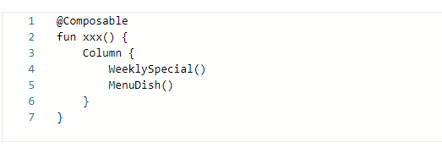

1. BottomPanel
2. MenuDish
3. LowerPanel
4. In this exercise, Image composable loads the image from drawable using __________.
5. drawable using painterResource()
6. resource()
7. drawableResource()
8. In this exercise, which listener was used to perform an action after the button is clicked?
9. onKeyListener
10. onClickListener
11. onMouseListener

1-c 2-a 3-b

# Knowledge check: Modifiers and Interactivity

1.Which of these is true for modifiers?

1. They change the container of a composable
2. They must be provided for every composable
3. They change how a composable behaves or appears.

2. The composable argument that would replace xxxx in the code below is known as a:

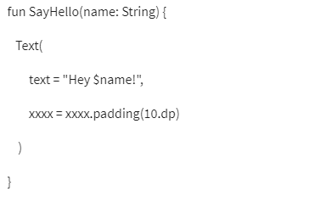

1. Modifier
2. Compose
3. Augmenter

3. What is the order of precedence for modifier chaining in Android UI Development?

1. Themes, Widgets, Layout
2. Layout, Themes, Widgets
3. Widgets, Layout, Themes

4. What is the best way to handle an event in Android UI Development?

1. Augment composables
2. Use a switch statement.
3. Implement an OnClickListener interface.

5.Which of these event modifiers is used when the app user presses a mouse button?

1. Shift
2. Meta
3. Control
4. Alt
5. Action

1-c 2-a 3-c 4-c 5-a,b,c,d

# Self-review: Managing state in Compose

1. In this exercise, the padding Modifier was used to properly space composables.

1. True
2. False

2. In this exercise, which callback was used to monitor the Text composable value change?

1. onValueUpdate
2. onTextChange
3. onValueChange

3. In the exercise, how was the username and password retrieved from Text composable?

1. using field property
2. using text property
3. using string property

1-a 2-c 3-b

# Knowledge check: Managing state

1. Not all ‘events’ in an Android app happen due to user interaction.

1. True
2. False

2.What does 'Recomposition' in Jetpack Compose allow developers to do?

1. Refresh the UI whenever the data changes.
2. Write new code without editing existing code.
3. Reuse existing code

3. In Jetpack Compose what does the mutableStateOf function create?

1. State that can be changed over time.
2. An immutable state of code
3. A fixed state of data

4. A composable holding and modifying its state internally is called a ____________.

1. Stateful Recomposition
2. Stateful composable
3. Stateless composable

5. What is the main purpose of State Hoisting in Android UI Development?

1. To aid in debugging an application
2. To store and restore UI states during configuration changes
3. To improve the performance of an Android application

1-a 2-a 3-a 4-b 5-b

# Self-review: Building a responsive layout

1. In this exercise, what are the supported orientations?

1. Landscape
2. Portrait
3. horizontal

2. In this exercise device orientation was retrieved using configuration.landscape property.

1. True
2. False

3. In this exercise, how many layouts where used?

1. three layouts
2. two layouts
3. one layout

1-a,b 2-b 3-b

# Building UI with Jetpack Compose

1. In addition to modifying an aspect of a composable’s appearance, which of the following can modifiers also be used to modify?

styling

padding

decorators

behavior

2. How is the body of a scaffold defined?

as predefined properties

using modifiers

as a trailing lambda

with a composable function

3. Which of the following is the correct way to add a spacing of **10 dp** around all four sides of a text composable?

a)

b)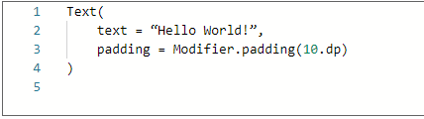

4. Which of the following is a keyword that retains the value of a state variable after recomposition?

1. **MutableStateOf**
2. **mutate**
3. **remember**
4. **mutableState**

5. Which of the following does the button composable expect you to define?

1. **onClick**
2. **onSubmit**
3. **onTap**
4. **onPress**

6. Which of the following is a UI pattern that provides a side-panel for navigating between different parts of the application?

1. **NavigationBar**
2. Navigation Drawer Scaffold
3. **BottomSheetScaffold**
4. Backdrop Scaffold

7. What are the individual UI elements called in Material Design?

1. components
2. Material Components
3. Design Elements
4. composables

8. Which of the following can a **slot** accept composable content as?

1. a composable function
2. a modifier
3. a Kotlin object
4. a generic lamba

9. Which of the following UI patterns normally opens by clicking a button on the top app bar or by swiping from the left edge of the screen to the right?

1. snackbars
2. floating action buttons
3. the navigation drawer
4. app bars

10. Which of the following is a common design structure found in many apps?

1. lambdas
2. Composables
3. UI Patterns
4. Slots

1-d 2-c 3-b 4-c 5-a 6-b 7-b 8-c 9-c 10-c